**Homework Helper**

**Equivalent Fractions & Comparing Fractions**

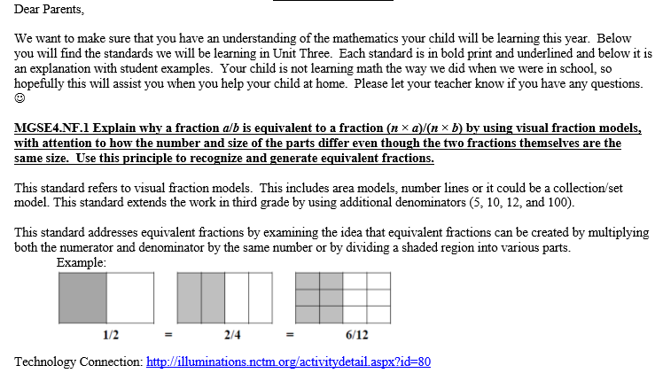

Vocabulary for this unit:

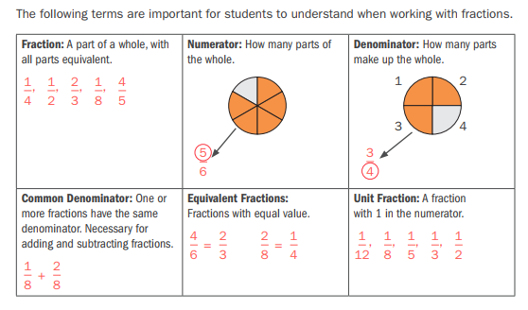

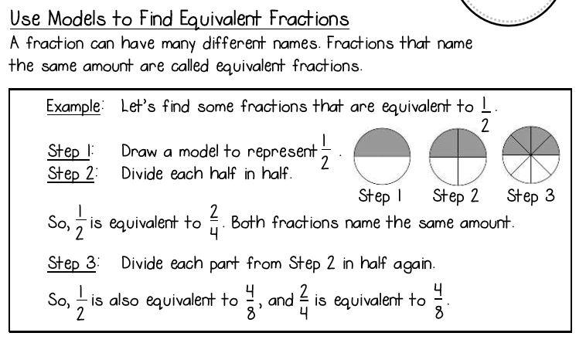

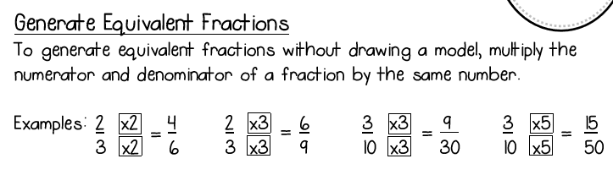

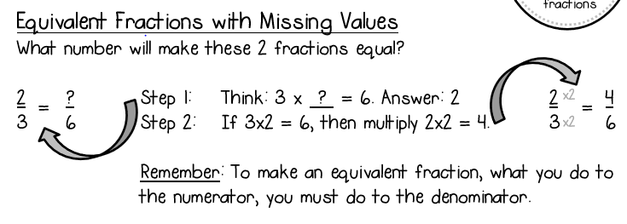

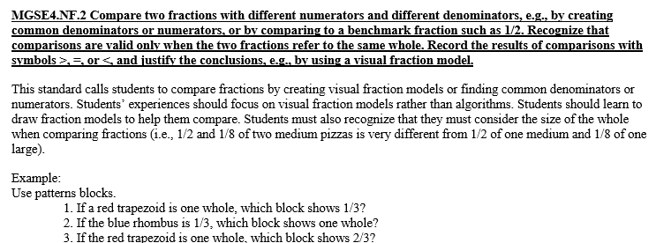

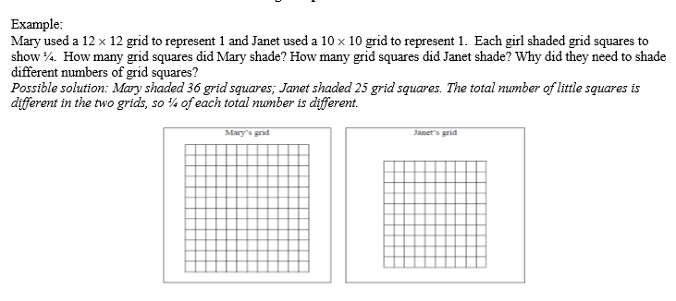

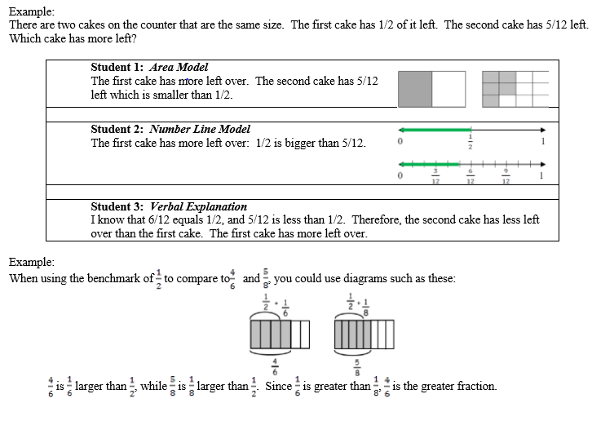

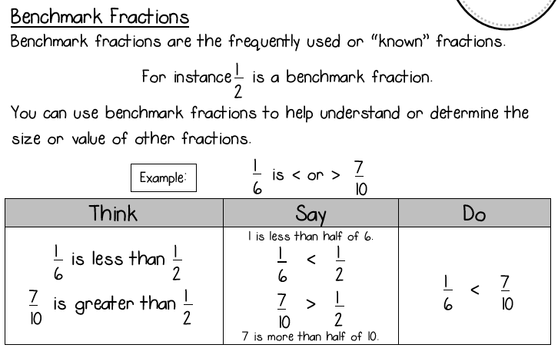

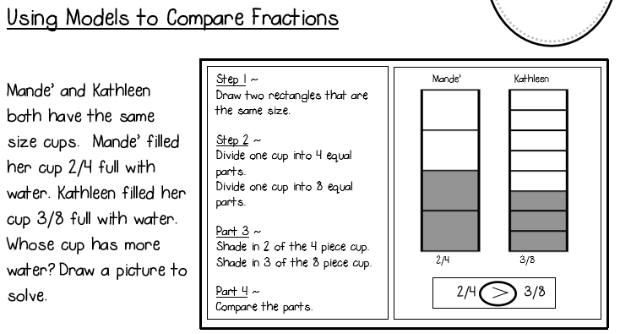

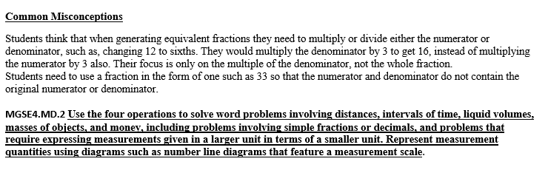

Review: Important Fractional Concepts

• Fractional parts must be equal sized.

• The number of equal parts tell how many make a whole.

• As the number of equal pieces in the whole increases, the size of the fractional pieces decreases.

• The size of the fraction is relative to the whole.

• When a whole is cut into equal parts, the denominator represents the number of equal parts.

• The numerator of a fraction is the count of the number of equal parts.